ASSIGNMENT -3

Design a login page look like facebook.com with follow requirements:

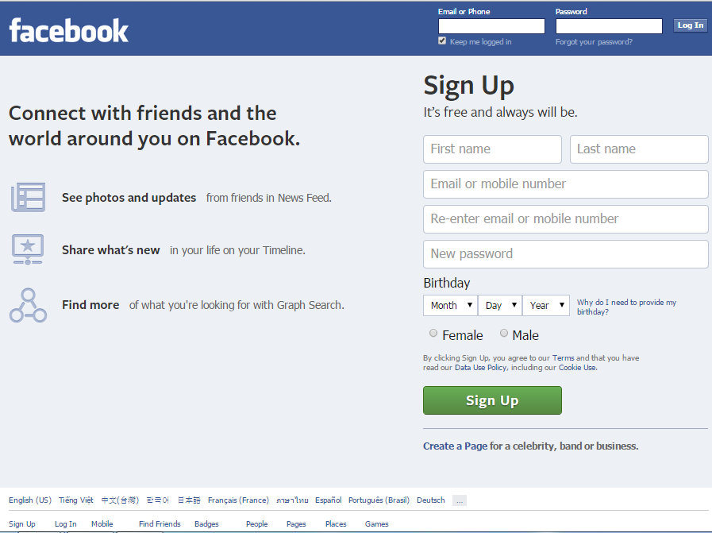

1. Design a structure of this page by using section or div.
2. Code the head section with title and metadata for this page.
3. Code Sign Up form and using HTML validation control to validate the input data by follow rules:
   1. First Name and Last Name don’t include the number and maximum 20 characters.
   2. Email must be correct email form.
   3. Retype email and email must be matched.
   4. Password should be correct password form and minimum 8 characters.
4. When Sign Up button click a java click will display a message “Welcome to Facebook”
5. Create a navigation bar like Sign up, login, mobile …

The End